**EX.NO:3 DATE:16/10/2024**

**Reg.no:220701012**

**DEPTH-FIRST SEARCH – WATER JUG PROBLEM**

In the water jug problem in Artificial Intelligence, we are provided with two jugs: one having

the capacity to hold 3 gallons of water and the other has the capacity to hold 4 gallons of water.

There is no other measuring equipment available and the jugs also do not have any kind of marking

on them. So, the agent’s task here is to fill the 4-gallon jug with 2 gallons of water by using only

these two jugs and no other material. Initially, both our jugs are empty.

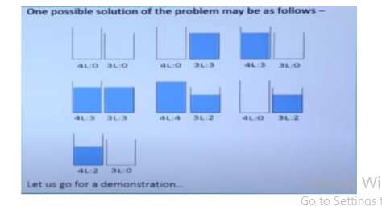

**CODE**:

def dfs(x, y, target, visited, path, a, b):

    if b == target:

        print("Solution found:")

        for step in path:

            print(step)

        return True

    if (a, b) in visited:

        return False

    visited.add((a, b))

    path.append(f"({a}, {b})")

    if dfs(x, y, target, visited, path, x, b):

        return True

    if dfs(x, y, target, visited, path, a, y):

        return True

    if dfs(x, y, target, visited, path, 0, b):

        return True

    if dfs(x, y, target, visited, path, a, 0):

        return True

    if a + b <= y:

        if dfs(x, y, target, visited, path, 0, a + b):

            return True

    else:

        if dfs(x, y, target, visited, path, a - (y - b), y):

            return True

    if a + b <= x:

        if dfs(x, y, target, visited, path, a + b, 0):

            return True

    else:

        if dfs(x, y, target, visited, path, x, b - (x - a)):

            return True

    path.pop()

    return False

def water_jug_dfs():

    x, y = 3, 4

    target = 2

    visited = set()

    path = []

    if not dfs(x, y, target, visited, path, 0, 0):

        print("No solution exists.")

water_jug_dfs()

**OUTPUT**:  
